

Programme Name: **BCS**

Course Code: **CSC 1612**

Course Name: **DATA COMMUNICATION AND NETWORKING**

**Open Book Examination**

Date of Submission: **10/11/2020**

**Submitted By: Submitted To:**

Student Name**: CSC 1612_Dipesh Tha Shrestha** Name: **SATYAM PAUDEL**

IUKL ID: **041902900028** Department: **LMS**

Semester: **Second**

Intake**: 2019 September**

**1. A network administrator has the range 192.168.50.0/24 to address the networks shown.**

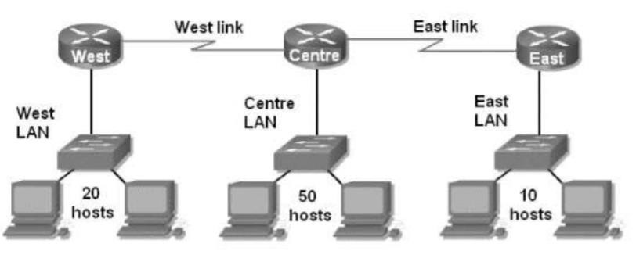

**A network administrator has the address range 192.168.50.0/24 to address the networks shown.**

1. **Fundamentally, IP addresses have network part of the address and host part of the address. Given the subnet information 192.168.50.0 /24. How many bits are in the network part of the address and how many are in the host part of the address?**

**Answer:**

We know that,

Network bits=prefix

Network bits=24

And network bits + host bits=32

So, host bits =32-network bits

Host bits=32-24

Host bits=8

1. **Looking at the above network diagram, how many networks are needed to be addressed?**

**Answer:**

Looking at the above diagram there are 80 hosts to be networked. And each having a three separate host and broadcasting id, there will be 86 network id’s.

1. **What would happen if you address the networks without using VLSM for the above network diagram? Could you explain your reason to it?**

**Answer:**

If we address the networks without using VLSM, then there will be wastage of IP address. Using FLSM, the address the of the networked will be allocated in a fixed length and it will divide IP equally to each network, even if the requirement is low. So, Without using VLSM, we will be wasting more IP addresses.

1. **Now that, you have started using VLSM to address the networks. Which network would you choose first to start addressing with? What is your idea behind this?**

**Answer:**

Since the network in center LAN has maximum number of hosts as compared to other networks. i.e. 50. So, we choose center LAN first to start addressing with.

1. **Referring to question no 4, you have decided to choose your first network to start addressing with. How many host bits do you require to address these hosts? Give reasoning to your answer**.

**Answer:**

we need 6 host bits to address the hosts in center LAN. As there are

50 hosts required, that means it includes network id and broadcast id. So, we need 52 IP addresses. Taking 52 hosts is not possible as a whole, to accommodate we have to go to 2^6 IP addresses. And hence making the required host bits up to

6.

1. **Referring to question no 4 and 5, you have decided to choose your first network to start addressing with. What will be the subnet mask for this network?**

**Answer:**

The subnet mask will be /26 i.e. 255.255.255.192.

1. **Now that you have finished addressing the first network. How many hosts will be needed on your second biggest LAN?**

**Answer:**

We have 20 hosts but it should include the network and host id. So, we need 22 hosts ids.

1. **Referring to Question no 7. How many host bits do you need to address this number of hosts? Give reasoning to your decision.**

**Answer:**

we need 5 host bits. As 22 hosts id is needed, and it cannot be accommodated exactly on 22. So, we arrange the 22 host bits on 2^5 bits i.e. 32 id’s.

1. **Now that you have dealt with the basic of the VLSM. Construct a complete table in below format showing VLSM addressing for the above network diagram. Mention subnet name, subnet mask, network address and broadcast address for each and every network**

|  |  |  |  |
| --- | --- | --- | --- |
| Subnet name | Network address | Broad cast address | Subnet mask |
| Centre LAN | 192.168.50.0 | 192.168.50.63 | /26 |
| West LAN | 192.168.50.64 | 192.168.50.95 | /27 |
| East LAN | 192.168.50.96 | 192.168.5.111 | /28 |

**2. Assume that on the sender side data is 10110 and Code generator polynomial is: x^3+x^2+1. After the data transmission is done, assume the receiver has received message: 10110110. Using Cyclic Redundancy Check as the Error Detection technique, Answer the following question:**

1. **Evaluate the code word after code generation on the sender side.**

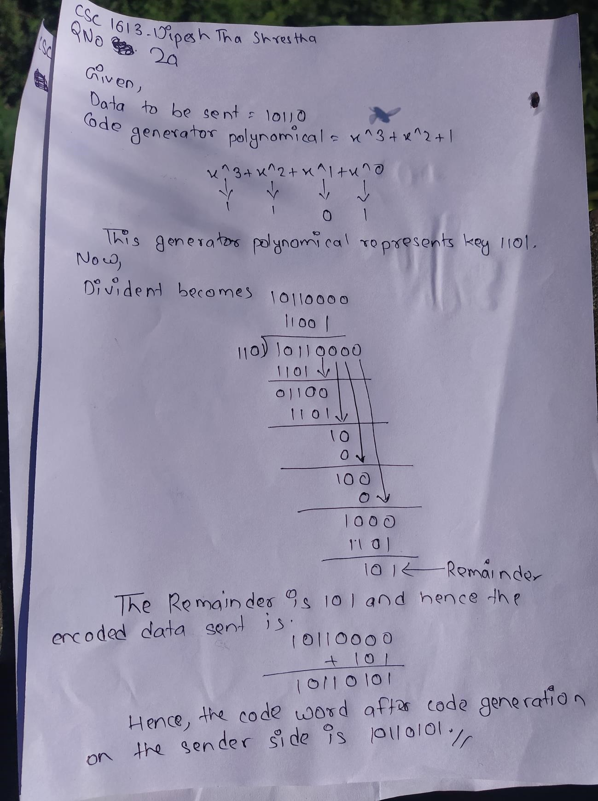

1. **Calculate the remainder on the receiving side. Show the steps involved.**

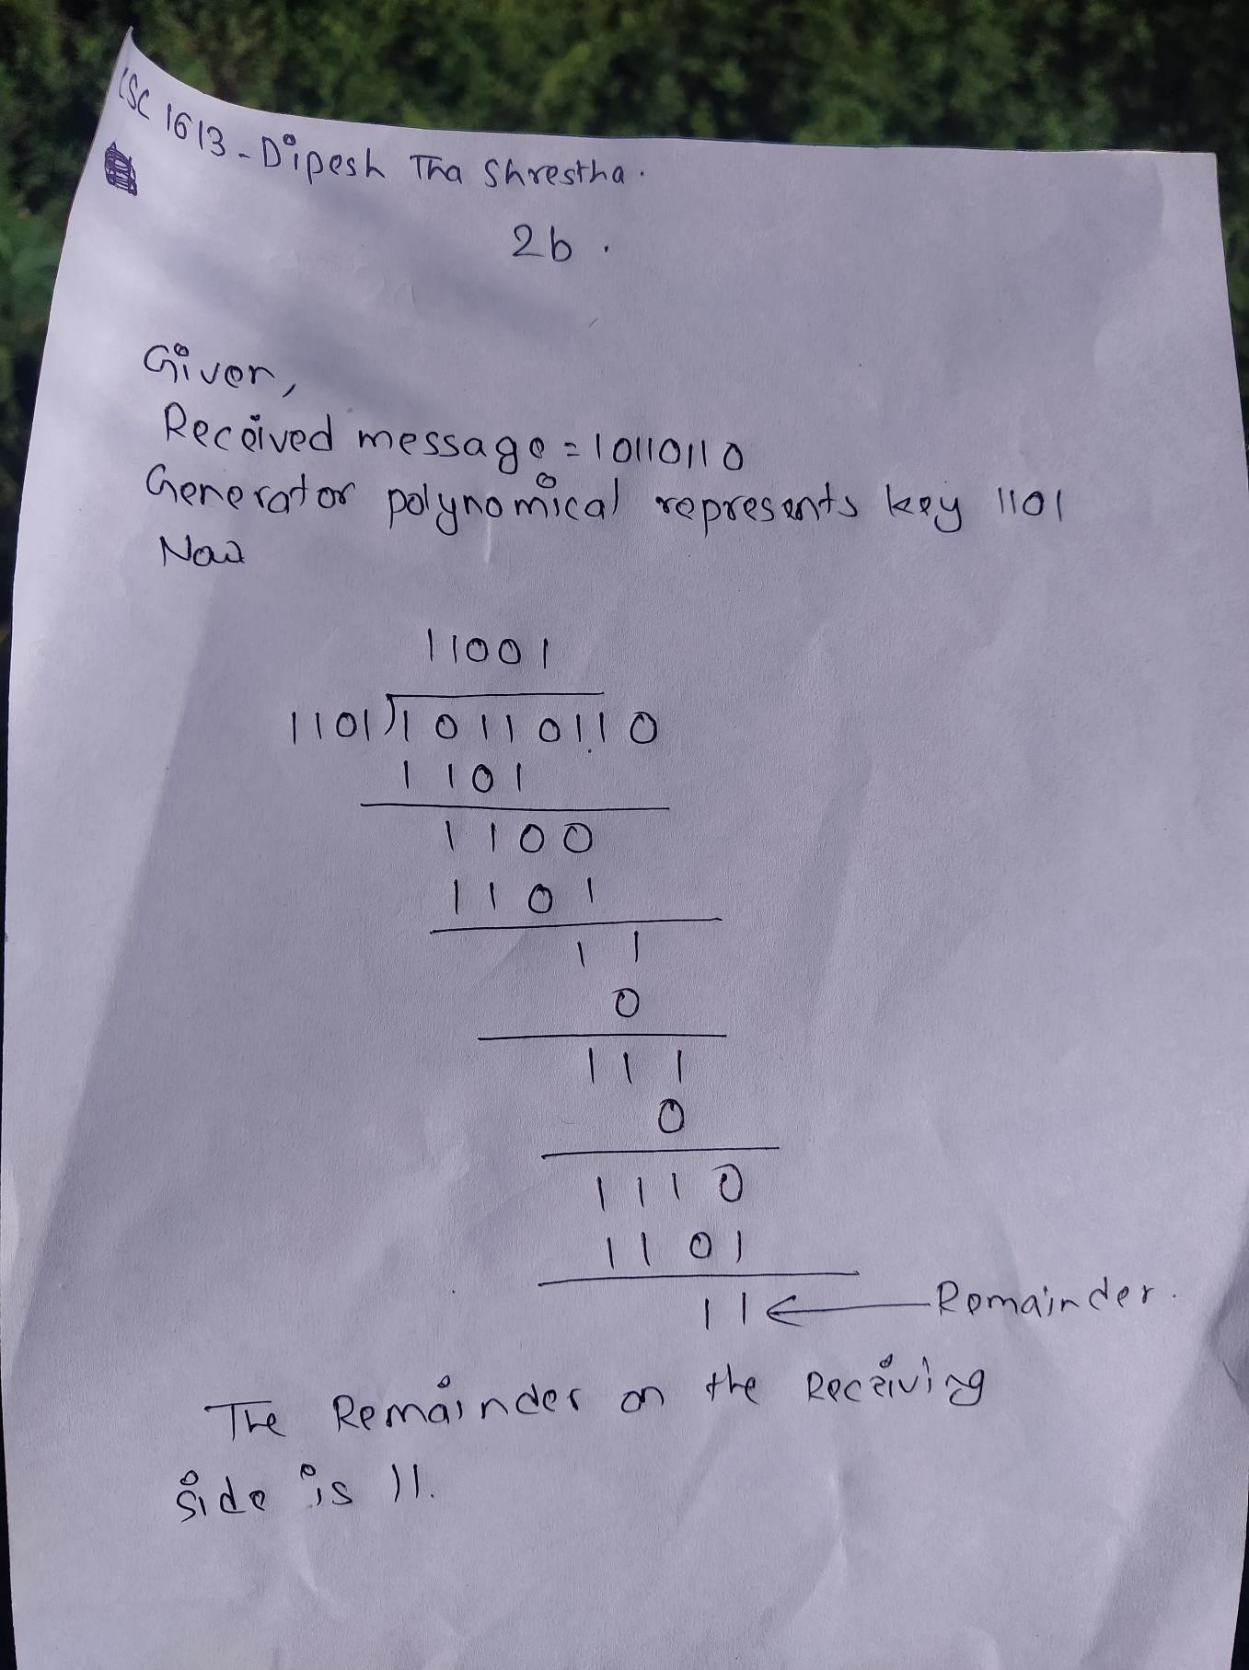

1. **Has error occurred during the transmission? Justify** Answer:

Error has occurred during the transmission. From question (a) and (b) we find that. The encoded data is; 10110101 and at the receiver side during decoding the data 10110110 at receiver we need to have remainder 0000 to be sure of error free data but here we have the error on receiver side that is remainder: 11. So, we have the error on data transmission. Hence to conclude the data sent 10110101 is not equal to the data received 10110110 where we have error on transmission and the error is 11.

3. **An IT company in London has hired you as a Network Engineer. As a part of the job, you have been requested to configure router. Write complete command to configure the router.**

**a. Name of the router to infosys1**

Router>enable

Router#config terminal

Enter configuration commands, one per line.End with CNTL/Z. Router(config) #hostname infosys1

infosys1(config)#

**b.Set banner message as “You are not an authorized user. Strict action will be taken”.**

Router>enable

Router#config terminal

Enter configuration commands, one per line. End with CNTL/Z.

Router(Config) #banner motd #You are not an authorized user. Strict action will be taken#

**c.Assign IP address to Vlan1. The IP address is 200.182.119.1 and subnet mask is 255.255.255.224. Also, change the state to active mode.**

Router>enable

Router#config terminal

Enter configuration commands, one per line.End with CNTL/Z.

Router(config) #interface gigabitEthernet 0/0/0

Router(config-if) #ip address 200.182.119.1 255.255.255.0

Router(config-if) #no shutdown

Router(config-if) #%LINK-5-CHNAGED: Interface GigabitEthernet0/0/0, Changed state to up

%LINEPROTO-5_UPDOWN: Line protocol on Interface GigabitEthernet0/0/0, Changed state to up

**d. While configuring the network, you want to check if the host**

**200.182.119.3 is available in the network? List out the command to check if the host 200.182.119.3 is responding or not.**

**Answer:**

To check whether the host is available in network or not or its responding we can do use following command .

Command 1 : ping 200.182.119.3

If the host is active, the ping command send package from sender and also ask for package from host in order to check the connection.

Command 2 : show ip route

The above command show the list of all connection. This table help use to find whether the host is available or not.

Command 3 : show ip interface brief

The above command show the list if ip connection in network in list. This table help use to find whether the host is available or not.

**e. Telnet is a protocol virtually used to access a computer. As a network administrator you are required to provide remote access to currently configured network 202.182.119.1 from a computer which is in another network. List out the commands and steps to perform this action ( Include Password Configuration and remote access command from remote computer) Answer:**

To make our switch or router or our host into remote accessible device the following steps should be followed.

(This command need to be enter into the device where remote access need to be configure)

Step 1: enable

Step 2: config terminal

Step 3: enable password admin

Step 4: int VLAN 1

Step 5: ip address 202.182.119.1 255.255.255.0

Step 6: no shut

After this steps has been done. To access it or remote control it, device or pc in same network can follow this following step to get remote access.

(This command need to be enter into remote accessing want device)

This command are need to be enter in command line

Step 1: telnet 202.182.119.1

Trying 202.182.119.1….open

User Access Verification

Password : admin

Switch>

Here after entering password, we have a access to our remote device.

**f. Assume that you want to see the passwords that you have configured in different levels of IOS modes. Mention the best possible way to do it.**

**Answer:**

The best possible way to see all the password we enter in different level of ISO modes is :

1 : show history

After running all the command and at the end before loging out, we can use this command to see all the command we enter in this device

2: service password-encryption

We need to be in config mod , and this will show all the password in human readable form.

**g. After configuring, all the changes are saved to running configuration which you have to save it to startup configuration. List the step to perform this task.**

**Answer:**

To save all the configuration after setting up, we need to do following step to save it in memory. So, that after startup our configure should not be wipe and stay save.

(After writing all the command and configuration )

Command : write memory Building configuration….

[ok]